



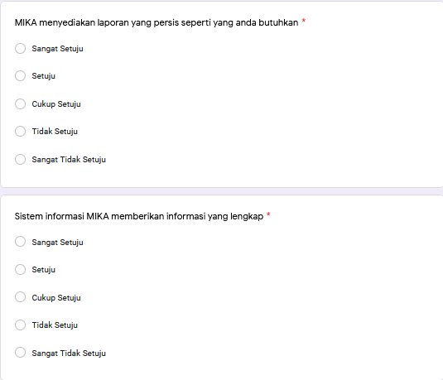

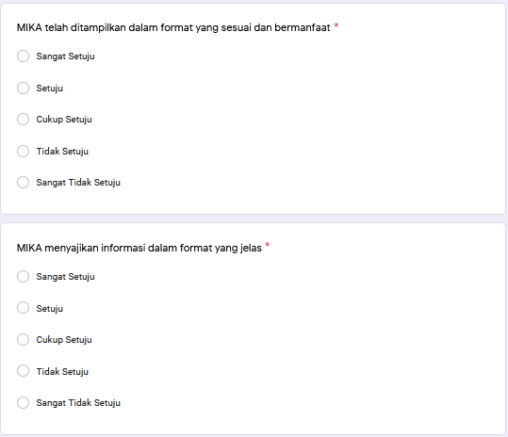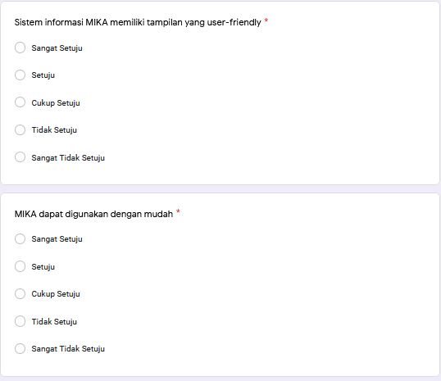

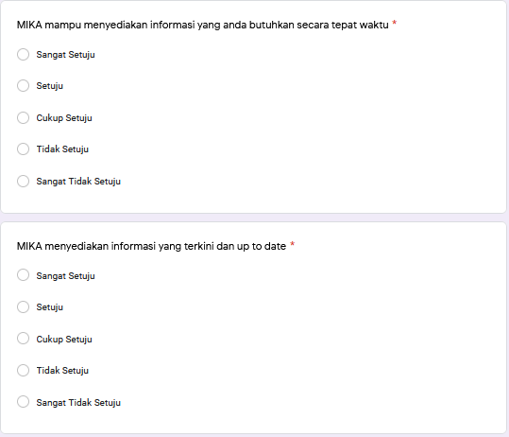

|  |  |  |  |  |  |  |  |  |  |  |  |  |  |
| --- | --- | --- | --- | --- | --- | --- | --- | --- | --- | --- | --- | --- | --- |
| 3 | 2 | 4 | 4 | 3 | 3 | 3 | 3 | 3 | 4 | 4 | 4 | 3 | 4 |
| 4 | 4 | 3 | 4 | 3 | 5 | 3 | 5 | 3 | 3 | 2 | 2 | 2 | 2 |
| 5 | 4 | 5 | 4 | 4 | 5 | 4 | 5 | 5 | 5 | 5 | 4 | 5 | 5 |
| 4 | 3 | 4 | 4 | 4 | 3 | 4 | 4 | 3 | 3 | 4 | 3 | 4 | 3 |
| 5 | 5 | 5 | 5 | 5 | 5 | 4 | 5 | 5 | 5 | 5 | 5 | 5 | 5 |
| 4 | 4 | 4 | 4 | 4 | 4 | 4 | 4 | 3 | 3 | 4 | 4 | 4 | 4 |
| 5 | 5 | 5 | 5 | 5 | 5 | 4 | 4 | 5 | 5 | 5 | 5 | 5 | 5 |
| 4 | 4 | 4 | 4 | 4 | 4 | 3 | 3 | 4 | 2 | 3 | 4 | 4 | 4 |
| 4 | 4 | 4 | 4 | 4 | 4 | 4 | 4 | 4 | 4 | 3 | 4 | 4 | 4 |
| 4 | 4 | 4 | 4 | 5 | 5 | 4 | 4 | 3 | 3 | 3 | 4 | 4 | 5 |
| 4 | 4 | 4 | 4 | 4 | 4 | 4 | 4 | 4 | 4 | 4 | 4 | 4 | 4 |
| 5 | 4 | 4 | 5 | 4 | 3 | 4 | 4 | 4 | 5 | 5 | 4 | 4 | 3 |
| 4 | 4 | 4 | 4 | 4 | 4 | 4 | 4 | 4 | 4 | 4 | 4 | 4 | 4 |
| 5 | 5 | 5 | 5 | 5 | 5 | 5 | 5 | 5 | 5 | 5 | 5 | 5 | 5 |
| 4 | 4 | 4 | 4 | 4 | 4 | 4 | 4 | 4 | 4 | 4 | 4 | 4 | 4 |
| 4 | 4 | 4 | 4 | 4 | 4 | 4 | 4 | 4 | 4 | 4 | 4 | 4 | 4 |
| 3 | 3 | 3 | 3 | 3 | 3 | 3 | 3 | 2 | 3 | 3 | 3 | 3 | 3 |
| 3 | 3 | 4 | 2 | 5 | 4 | 3 | 3 | 4 | 4 | 3 | 3 | 4 | 4 |
| 5 | 5 | 3 | 5 | 4 | 4 | 3 | 4 | 5 | 5 | 5 | 4 | 5 | 4 |
| 4 | 5 | 4 | 5 | 4 | 4 | 4 | 4 | 4 | 5 | 4 | 5 | 4 | 5 |
| 5 | 5 | 5 | 5 | 5 | 5 | 5 | 5 | 4 | 4 | 5 | 5 | 5 | 5 |
| 4 | 4 | 4 | 4 | 4 | 4 | 4 | 4 | 4 | 4 | 4 | 4 | 4 | 4 |
| 5 | 5 | 5 | 5 | 5 | 5 | 5 | 5 | 5 | 5 | 5 | 5 | 5 | 5 |
| 5 | 5 | 5 | 5 | 5 | 5 | 5 | 5 | 4 | 5 | 5 | 5 | 4 | 5 |
| 5 | 5 | 5 | 4 | 4 | 4 | 5 | 4 | 4 | 4 | 5 | 4 | 4 | 4 |
| 5 | 4 | 4 | 5 | 4 | 4 | 4 | 5 | 3 | 3 | 5 | 5 | 4 | 5 |
| 4 | 5 | 4 | 4 | 4 | 4 | 3 | 4 | 4 | 4 | 4 | 4 | 4 | 4 |
| 5 | 4 | 4 | 4 | 5 | 5 | 4 | 5 | 4 | 5 | 5 | 4 | 4 | 5 |
| 4 | 3 | 3 | 5 | 4 | 3 | 3 | 3 | 3 | 3 | 3 | 3 | 3 | 3 |
| 4 | 4 | 4 | 4 | 3 | 3 | 3 | 3 | 3 | 3 | 4 | 4 | 3 | 3 |
| 4 | 4 | 4 | 4 | 4 | 4 | 4 | 4 | 4 | 4 | 4 | 4 | 4 | 4 |
| 5 | 5 | 4 | 5 | 5 | 5 | 5 | 5 | 4 | 5 | 5 | 5 | 4 | 5 |
| 5 | 4 | 3 | 4 | 4 | 5 | 5 | 3 | 3 | 4 | 2 | 5 | 3 | 4 |
| 3 | 3 | 3 | 3 | 3 | 3 | 3 | 3 | 2 | 2 | 3 | 3 | 3 | 3 |
| 4 | 4 | 4 | 4 | 4 | 4 | 4 | 4 | 4 | 4 | 4 | 4 | 4 | 4 |
| 3 | 3 | 3 | 3 | 3 | 3 | 3 | 3 | 3 | 3 | 3 | 3 | 3 | 3 |
| 5 | 5 | 5 | 5 | 5 | 5 | 5 | 5 | 5 | 5 | 5 | 5 | 5 | 5 |
| 4 | 4 | 4 | 4 | 4 | 4 | 4 | 4 | 4 | 4 | 4 | 4 | 4 | 4 |
| 5 | 5 | 5 | 4 | 5 | 5 | 5 | 5 | 4 | 4 | 4 | 5 | 4 | 4 |
| 5 | 5 | 5 | 5 | 5 | 4 | 4 | 5 | 5 | 5 | 5 | 5 | 5 | 5 |
| 4 | 4 | 4 | 4 | 4 | 5 | 5 | 5 | 4 | 5 | 5 | 4 | 4 | 5 |
| 4 | 4 | 5 | 3 | 4 | 4 | 4 | 4 | 4 | 3 | 4 | 4 | 4 | 4 |
| 4 | 4 | 4 | 4 | 4 | 4 | 4 | 4 | 4 | 4 | 4 | 4 | 4 | 4 |
| 4 | 5 | 3 | 5 | 3 | 3 | 5 | 5 | 5 | 5 | 5 | 5 | 5 | 5 |
| 5 | 5 | 5 | 5 | 5 | 5 | 5 | 5 | 5 | 5 | 5 | 5 | 5 | 5 |
| 4 | 4 | 4 | 4 | 4 | 4 | 4 | 4 | 5 | 4 | 4 | 4 | 5 | 4 |
| 4 | 4 | 4 | 4 | 4 | 4 | 4 | 4 | 4 | 4 | 4 | 4 | 4 | 4 |
| 5 | 5 | 5 | 5 | 5 | 5 | 5 | 5 | 5 | 5 | 5 | 5 | 5 | 5 |
| 4 | 4 | 4 | 4 | 4 | 4 | 4 | 4 | 4 | 4 | 4 | 4 | 4 | 4 |
| 4 | 4 | 4 | 4 | 5 | 4 | 3 | 3 | 5 | 4 | 4 | 4 | 5 | 4 |
| 5 | 5 | 4 | 5 | 5 | 5 | 4 | 4 | 4 | 5 | 5 | 5 | 4 | 5 |
| 3 | 3 | 3 | 3 | 3 | 3 | 3 | 3 | 3 | 3 | 3 | 3 | 3 | 3 |
| 5 | 5 | 4 | 5 | 5 | 5 | 4 | 5 | 5 | 4 | 5 | 5 | 4 | 5 |
| 3 | 4 | 4 | 3 | 5 | 4 | 4 | 3 | 2 | 3 | 4 | 3 | 4 | 3 |
| 4 | 4 | 4 | 4 | 3 | 3 | 4 | 3 | 3 | 3 | 3 | 4 | 3 | 4 |
| 3 | 3 | 3 | 3 | 3 | 3 | 3 | 3 | 3 | 3 | 3 | 3 | 3 | 3 |
| 3 | 4 | 4 | 4 | 4 | 3 | 4 | 4 | 4 | 4 | 2 | 3 | 4 | 4 |
| 5 | 4 | 4 | 4 | 5 | 5 | 5 | 5 | 5 | 5 | 5 | 5 | 5 | 5 |
| 4 | 5 | 4 | 4 | 4 | 4 | 4 | 4 | 4 | 4 | 4 | 4 | 4 | 4 |
| 5 | 4 | 4 | 5 | 4 | 4 | 3 | 4 | 3 | 3 | 4 | 5 | 4 | 5 |
| 5 | 5 | 5 | 5 | 5 | 5 | 5 | 5 | 5 | 5 | 5 | 5 | 5 | 5 |
| 5 | 5 | 5 | 5 | 5 | 5 | 5 | 5 | 5 | 5 | 5 | 5 | 5 | 5 |
| 5 | 4 | 5 | 4 | 5 | 5 | 5 | 5 | 5 | 5 | 5 | 4 | 5 | 4 |
| 4 | 5 | 4 | 5 | 4 | 4 | 4 | 5 | 4 | 5 | 5 | 4 | 4 | 5 |
| 4 | 5 | 4 | 4 | 4 | 4 | 5 | 5 | 4 | 4 | 4 | 5 | 4 | 4 |
| 4 | 4 | 3 | 3 | 4 | 4 | 3 | 3 | 4 | 4 | 3 | 4 | 4 | 4 |
| 5 | 5 | 5 | 5 | 5 | 5 | 5 | 5 | 4 | 5 | 5 | 5 | 4 | 5 |
| 4 | 4 | 4 | 3 | 4 | 4 | 4 | 2 | 4 | 4 | 4 | 4 | 4 | 4 |
| 4 | 4 | 4 | 3 | 4 | 4 | 4 | 4 | 4 | 4 | 4 | 4 | 4 | 4 |
| 5 | 5 | 5 | 5 | 5 | 5 | 5 | 5 | 3 | 3 | 5 | 5 | 5 | 5 |
| 4 | 4 | 4 | 5 | 5 | 4 | 5 | 5 | 4 | 5 | 5 | 5 | 4 | 5 |
| 5 | 4 | 4 | 4 | 4 | 4 | 4 | 4 | 4 | 4 | 4 | 4 | 4 | 4 |
| 5 | 5 | 5 | 5 | 5 | 5 | 5 | 5 | 5 | 5 | 5 | 5 | 5 | 5 |
| 5 | 4 | 4 | 4 | 4 | 4 | 4 | 4 | 4 | 4 | 4 | 4 | 4 | 4 |
| 4 | 4 | 4 | 4 | 3 | 4 | 4 | 4 | 3 | 3 | 3 | 3 | 3 | 3 |
| 4 | 4 | 4 | 4 | 4 | 4 | 4 | 4 | 4 | 4 | 4 | 4 | 4 | 4 |
| 4 | 3 | 3 | 3 | 4 | 3 | 4 | 3 | 4 | 3 | 2 | 3 | 4 | 3 |
| 4 | 4 | 4 | 4 | 4 | 4 | 4 | 4 | 4 | 4 | 5 | 5 | 4 | 4 |
| 4 | 4 | 4 | 4 | 4 | 4 | 4 | 4 | 4 | 4 | 4 | 4 | 4 | 4 |
| 5 | 4 | 4 | 4 | 5 | 4 | 4 | 4 | 4 | 5 | 5 | 4 | 4 | 5 |
| 4 | 4 | 4 | 4 | 4 | 4 | 4 | 4 | 4 | 4 | 4 | 4 | 4 | 4 |
| 5 | 5 | 5 | 5 | 5 | 5 | 5 | 5 | 5 | 5 | 5 | 5 | 5 | 5 |
| 5 | 5 | 5 | 5 | 5 | 5 | 5 | 5 | 3 | 4 | 5 | 5 | 3 | 4 |
| 5 | 5 | 5 | 5 | 5 | 5 | 4 | 5 | 4 | 4 | 5 | 5 | 4 | 4 |
| 5 | 5 | 5 | 5 | 5 | 5 | 5 | 5 | 5 | 5 | 5 | 5 | 5 | 5 |
| 4 | 4 | 4 | 4 | 4 | 4 | 4 | 4 | 4 | 4 | 4 | 4 | 4 | 4 |
| 5 | 5 | 5 | 5 | 5 | 5 | 5 | 5 | 5 | 5 | 5 | 5 | 5 | 5 |
| 4 | 4 | 4 | 4 | 4 | 4 | 4 | 4 | 4 | 4 | 4 | 4 | 4 | 4 |
| 4 | 4 | 4 | 4 | 4 | 4 | 4 | 4 | 4 | 5 | 4 | 4 | 4 | 5 |
| 5 | 5 | 5 | 5 | 5 | 5 | 5 | 5 | 5 | 5 | 5 | 5 | 5 | 5 |
| 4 | 4 | 4 | 4 | 4 | 4 | 4 | 4 | 4 | 4 | 4 | 4 | 4 | 4 |
| 3 | 4 | 4 | 4 | 5 | 4 | 4 | 4 | 4 | 4 | 3 | 4 | 4 | 4 |
| 4 | 4 | 4 | 4 | 4 | 4 | 4 | 4 | 4 | 4 | 4 | 4 | 4 | 4 |
| 4 | 4 | 3 | 3 | 4 | 3 | 4 | 4 | 4 | 4 | 3 | 4 | 4 | 3 |
| 5 | 5 | 5 | 5 | 5 | 5 | 5 | 5 | 5 | 5 | 5 | 5 | 5 | 5 |
| 4 | 5 | 4 | 5 | 5 | 4 | 3 | 3 | 4 | 4 | 5 | 5 | 5 | 5 |

Validitas

|  |  |  |  |  |  |  |
| --- | --- | --- | --- | --- | --- | --- |
| **Correlations** | | | | | | |
|  | | C1 | C2 | C3 | C4 | Total |
| C1 | Pearson Correlation | 1 | .699** | .634** | .709** | .881** |
| Sig. (2-tailed) |  | .000 | .000 | .000 | .000 |
| N | 96 | 96 | 96 | 96 | 96 |
| C2 | Pearson Correlation | .699** | 1 | .639** | .719** | .887** |
| Sig. (2-tailed) | .000 |  | .000 | .000 | .000 |
| N | 96 | 96 | 96 | 96 | 96 |
| C3 | Pearson Correlation | .634** | .639** | 1 | .547** | .811** |
| Sig. (2-tailed) | .000 | .000 |  | .000 | .000 |
| N | 96 | 96 | 96 | 96 | 96 |
| C4 | Pearson Correlation | .709** | .719** | .547** | 1 | .869** |
| Sig. (2-tailed) | .000 | .000 | .000 |  | .000 |
| N | 96 | 96 | 96 | 96 | 96 |
| Total | Pearson Correlation | .881** | .887** | .811** | .869** | 1 |
| Sig. (2-tailed) | .000 | .000 | .000 | .000 |  |
| N | 96 | 96 | 96 | 96 | 96 |
| **. Correlation is significant at the 0.01 level (2-tailed). | | | | | | |

|  |  |  |  |  |
| --- | --- | --- | --- | --- |
| **Correlations** | | | | |
|  | | A1 | A2 | Total |
| A1 | Pearson Correlation | 1 | .751** | .933** |
| Sig. (2-tailed) |  | .000 | .000 |
| N | 96 | 96 | 96 |
| A2 | Pearson Correlation | .751** | 1 | .939** |
| Sig. (2-tailed) | .000 |  | .000 |
| N | 96 | 96 | 96 |
| Total | Pearson Correlation | .933** | .939** | 1 |
| Sig. (2-tailed) | .000 | .000 |  |
| N | 96 | 96 | 96 |
| **. Correlation is significant at the 0.01 level (2-tailed). | | | | |

|  |  |  |  |  |
| --- | --- | --- | --- | --- |
| **Correlations** | | | | |
|  | | F1 | F2 | Total |
| F1 | Pearson Correlation | 1 | .728** | .922** |
| Sig. (2-tailed) |  | .000 | .000 |
| N | 96 | 96 | 96 |
| F2 | Pearson Correlation | .728** | 1 | .937** |
| Sig. (2-tailed) | .000 |  | .000 |
| N | 96 | 96 | 96 |
| Total | Pearson Correlation | .922** | .937** | 1 |
| Sig. (2-tailed) | .000 | .000 |  |
| N | 96 | 96 | 96 |
| **. Correlation is significant at the 0.01 level (2-tailed). | | | | |

|  |  |  |  |  |
| --- | --- | --- | --- | --- |
| **Correlations** | | | | |
|  | | E1 | E2 | Total |
| E1 | Pearson Correlation | 1 | .775** | .940** |
| Sig. (2-tailed) |  | .000 | .000 |
| N | 96 | 96 | 96 |
| E2 | Pearson Correlation | .775** | 1 | .945** |
| Sig. (2-tailed) | .000 |  | .000 |
| N | 96 | 96 | 96 |
| Total | Pearson Correlation | .940** | .945** | 1 |
| Sig. (2-tailed) | .000 | .000 |  |
| N | 96 | 96 | 96 |
| **. Correlation is significant at the 0.01 level (2-tailed). | | | | |

|  |  |  |  |  |
| --- | --- | --- | --- | --- |
| **Correlations** | | | | |
|  | | T1 | T2 | Total |
| T1 | Pearson Correlation | 1 | .727** | .942** |
| Sig. (2-tailed) |  | .000 | .000 |
| N | 96 | 96 | 96 |
| T2 | Pearson Correlation | .727** | 1 | .915** |
| Sig. (2-tailed) | .000 |  | .000 |
| N | 96 | 96 | 96 |
| Total | Pearson Correlation | .942** | .915** | 1 |
| Sig. (2-tailed) | .000 | .000 |  |
| N | 96 | 96 | 96 |
| **. Correlation is significant at the 0.01 level (2-tailed). | | | | |

|  |  |  |  |  |
| --- | --- | --- | --- | --- |
| **Correlations** | | | | |
|  | | Y1 | Y2 | Total |
| Y1 | Pearson Correlation | 1 | .702** | .915** |
| Sig. (2-tailed) |  | .000 | .000 |
| N | 96 | 96 | 96 |
| Y2 | Pearson Correlation | .702** | 1 | .930** |
| Sig. (2-tailed) | .000 |  | .000 |
| N | 96 | 96 | 96 |
| Total | Pearson Correlation | .915** | .930** | 1 |
| Sig. (2-tailed) | .000 | .000 |  |
| N | 96 | 96 | 96 |
| **. Correlation is significant at the 0.01 level (2-tailed). | | | | |

Reabilitas

|  |  |
| --- | --- |
| **Reliability Statistics** | |
| Cronbach's Alpha | N of Items |
| .885 | 4 |

|  |  |
| --- | --- |
| **Reliability Statistics** | |
| Cronbach's Alpha | N of Items |
| .858 | 2 |

|  |  |
| --- | --- |
| **Reliability Statistics** | |
| Cronbach's Alpha | N of Items |
| .840 | 2 |

|  |  |
| --- | --- |
| **Reliability Statistics** | |
| Cronbach's Alpha | N of Items |
| .873 | 2 |

|  |  |
| --- | --- |
| **Reliability Statistics** | |
| Cronbach's Alpha | N of Items |
| .834 | 2 |

|  |  |
| --- | --- |
| **Reliability Statistics** | |
| Cronbach's Alpha | N of Items |
| .823 | 2 |

Statistik Deskriptif

|  |  |  |  |  |  |
| --- | --- | --- | --- | --- | --- |
| **Descriptive Statistics** | | | | | |
|  | N | Minimum | Maximum | Mean | Std. Deviation |
| C1 | 96 | 3.00 | 5.00 | 4.3021 | .65083 |
| C2 | 96 | 2.00 | 5.00 | 4.2500 | .66491 |
| C3 | 96 | 3.00 | 5.00 | 4.1458 | .63211 |
| C4 | 96 | 2.00 | 5.00 | 4.2188 | .69892 |
| A1 | 96 | 3.00 | 5.00 | 4.2708 | .65661 |
| A2 | 96 | 3.00 | 5.00 | 4.1875 | .68537 |
| F1 | 96 | 3.00 | 5.00 | 4.1146 | .67854 |
| F2 | 96 | 2.00 | 5.00 | 4.1667 | .74927 |
| E1 | 96 | 2.00 | 5.00 | 4.0104 | .74685 |
| E2 | 96 | 2.00 | 5.00 | 4.1146 | .77961 |
| T1 | 96 | 2.00 | 5.00 | 4.1771 | .84598 |
| T2 | 96 | 2.00 | 5.00 | 4.2292 | .70306 |
| Y1 | 96 | 2.00 | 5.00 | 4.1250 | .65293 |
| Y2 | 96 | 2.00 | 5.00 | 4.2292 | .71788 |
| Valid N (listwise) | 96 |  |  |  |  |

Hasil Uji Multikolinearitas

VIF dan tolerance

|  |  |  |  |  |  |  |  |  |
| --- | --- | --- | --- | --- | --- | --- | --- | --- |
| **Coefficientsa** | | | | | | | | |
| Model | | Unstandardized Coefficients | | Standardized Coefficients | t | Sig. | Collinearity Statistics | |
| B | Std. Error | Beta | Tolerance | VIF |
| 1 | (Constant) | .993 | .474 |  | 2.094 | .039 |  |  |
| Content (X1) | -.026 | .065 | -.047 | -.399 | .691 | .170 | 5.870 |
| Accuracy (X2) | .261 | .081 | .259 | 3.225 | .002 | .359 | 2.786 |
| Format (X3) | -.076 | .078 | -.080 | -.979 | .330 | .345 | 2.895 |
| Ease of Use (X4) | .330 | .062 | .375 | 5.312 | .000 | .465 | 2.151 |
| Timeliness (X5) | .421 | .088 | .480 | 4.813 | .000 | .233 | 4.288 |
| a. Dependent Variable: User Satisfaction (Y) | | | | | | | | |

Uji Normalitas

Grafik normal P Plot

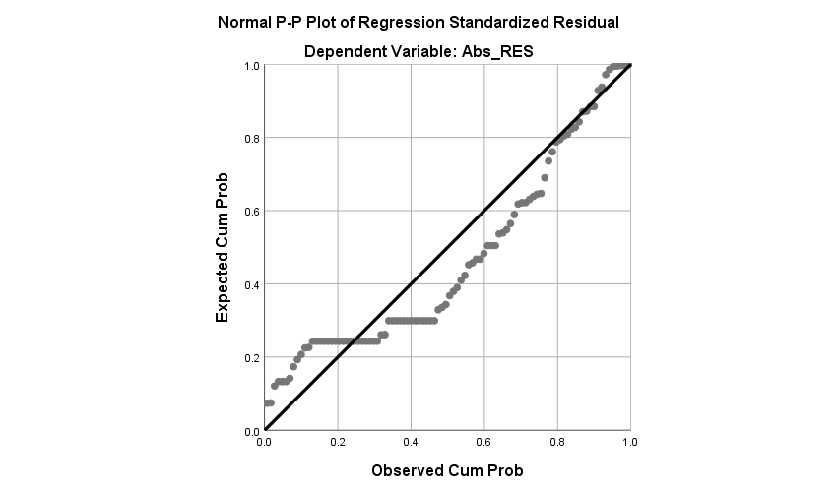

Uji Heteroskedastisitas

Grafik scatterplot

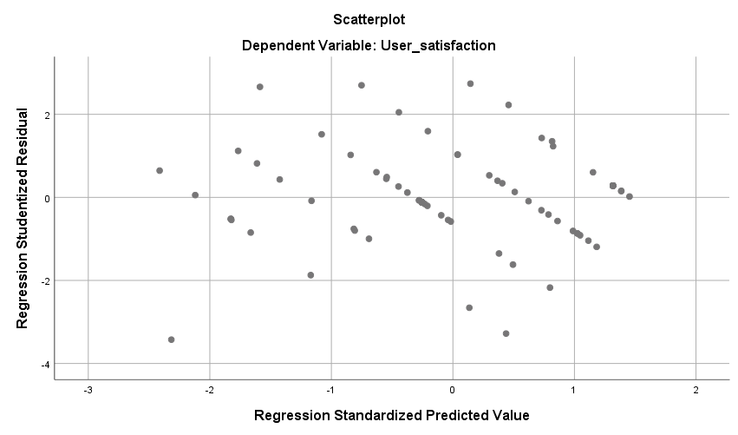

Uji glejser

T dan Sig

|  |  |  |  |  |  |  |  |  |
| --- | --- | --- | --- | --- | --- | --- | --- | --- |
| **Coefficientsa** | | | | | | | | |
| Model | | Unstandardized Coefficients | | Standardized Coefficients | t | Sig. | Collinearity Statistics | |
| B | Std. Error | Beta | Tolerance | VIF |
| 1 | (Constant) | .194 | .300 |  | .647 | .519 |  |  |
| Content (X1) | .130 | .041 | .704 | 3.194 | .002 | .170 | 5.870 |
| Accuracy (X2) | -.037 | .051 | -.111 | -.731 | .467 | .359 | 2.786 |
| Format (X3) | .034 | .049 | .108 | .695 | .489 | .345 | 2.895 |
| Ease of Use (X4) | -.175 | .039 | -.595 | -4.457 | .000 | .465 | 2.151 |
| Timeliness (X5) | -.066 | .055 | -.225 | -1.194 | .236 | .233 | 4.288 |
| a. Dependent Variable: Abs_RES | | | | | | | | |

Analisis Regresi Linear Berganda

B dan Std error dan coefficient beta

|  |  |  |  |  |  |  |
| --- | --- | --- | --- | --- | --- | --- |
| **Coefficientsa** | | | | | | |
| Model | | Unstandardized Coefficients | | Standardized Coefficients | t | Sig. |
| B | Std. Error | Beta |
| 1 | (Constant) | .993 | .474 |  | 2.094 | .039 |
| Content (X1) | -.026 | .065 | -.047 | -.399 | .691 |
| Accuracy (X2) | .261 | .081 | .259 | 3.225 | .002 |
| Format (X3) | -.076 | .078 | -.080 | -.979 | .330 |
| Ease of Use (X4) | .330 | .062 | .375 | 5.312 | .000 |
| Timeliness (X5) | .421 | .088 | .480 | 4.813 | .000 |
| a. Dependent Variable: User Satisfaction (Y) | | | | | | |

Pengujian Hipotesis :

Uji Koefisien Determinasi (R2)

|  |  |  |  |  |
| --- | --- | --- | --- | --- |
| **Model Summaryb** | | | | |
| Model | R | R Square | Adjusted R Square | Std. Error of the Estimate |
| 1 | .890a | .791 | .780 | .59359 |
| a. Predictors: (Constant), Timeliness (X5), Ease of Use (X4), Accuracy (X2), Format (X3), Content (X1) | | | | |
| b. Dependent Variable: User Satisfaction (Y) | | | | |

Uji t.

t dan Sig

|  |  |  |  |  |  |  |
| --- | --- | --- | --- | --- | --- | --- |
| **Coefficientsa** | | | | | | |
| Model | | Unstandardized Coefficients | | Standardized Coefficients | t | Sig. |
| B | Std. Error | Beta |
| 1 | (Constant) | .993 | .474 |  | 2.094 | .039 |
| Content (X1) | -.026 | .065 | -.047 | -.399 | .691 |
| Accuracy (X2) | .261 | .081 | .259 | 3.225 | .002 |
| Format (X3) | -.076 | .078 | -.080 | -.979 | .330 |
| Ease of Use (X4) | .330 | .062 | .375 | 5.312 | .000 |
| Timeliness (X5) | .421 | .088 | .480 | 4.813 | .000 |
| a. Dependent Variable: User Satisfaction (Y) | | | | | | |